Marcie Turjan  Pittsburgh, PA  814-659-7511  Marciet33@yahoo.com | 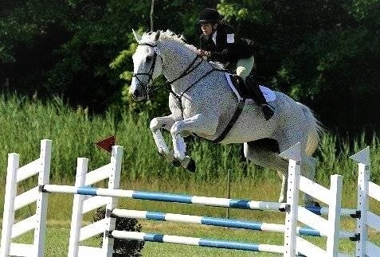
“Specializing in Eventing, Show Jumping and Pony Club for over 20 years”

MT Enterprise LLC | Full service enterprise catering to the equestrian lifestyle. Training for the horse and rider along with real estate assistance and business consulting for the equestrian enthusiast. Conduct comprehensive equine marketing studies, including business plans, strategy analysis, program development, training, and sales. Assist with Horse Association event planning, program development, facility layout, course design and judging. Provide instruction, coaching, and competition assistance to riders of all ages and levels.
South Ponte Vedra Equestrian Center | Deluxe eventing equestrian center. Boarding accommodations for 42 horses, two regulation sized sand jumping arenas, two grass dressage arenas, beginner friendly x-country course, 120 acres of riding trails. Full service training for horse and rider; starter to advanced level. Coaching and competition assistance for boarders. Onsite clinics, guest instructors, and competitions. Pony rides, trail rides and birthday parties are available for guest.
Fox Point Farm | Owner/Equine Sales Representative. Fox Point Farm is a small privately owned equine facility. We specialize in training quality sport horses for all disciplines. All horses are given experience in Hunters, Jumpers, Eventing, Foxhunting and basic Dressage. We represent clients and clients’ horses on a contract basis during transfer of ownership and handle the design of advertising strategies for marketing of equine focused products and services
Rolling Rock Hunt Pony Club-PA  St. Johns River Pony Club-FL | Instructor/Coach/Rater/Judge. Mentor and motivate young equestrian athletes and assist them in reaching their personal and competition goals. Develop riding and horse management skills based on a national standard of proficiency. Introduce different riding disciplines and teach rules and techniques associated with the different sports. Proven record of successfully coaching students from local to national competitions.  Promote and organize educational activities, competitions, riding camps, clinics, lesson programs and goal-oriented training programs. Provide judging services for competitions and regional testing.
Joseph Hardiman  Huntsman & Horse Trainer | Studied Show Jumping, Cross Country riding and Foxhunting techniques based on the Irish Horse Society standards. Responsible for starting and training young horses, competing and marketing horses to prospective buyers. Provided in-house vetting and care for horses and foxhound pack which included performing routine immunizations, worming, sutures, dental care, etc. Also rode as a whipper-in with Rolling Rock and Chagrin Valley Hunt Clubs.
Ellerslie Camperdown Hunt Club  Victoria, Australia | Managed hunt barn. Responsible for maintaining fitness levels of seasoned horses and training of young horses for the hunt field and staff. Horses were required to be amateur safe, content with hounds under foot, capable of jumping 4’0” wire fences, and fit enough for 5 hours of work.
Randall Veterinary Hospital  Dr. Ron Genovese  Warrensville Heights, Ohio | Examined and recorded vital signs and other parameters of the horses as they entered the clinic. Prepared horses for surgery, joint injections, nerve blocks, ultrasound analysis and x-rays. Acquired knowledge in the proper use of ultrasound, x-ray and nuclear bone scan equipment. Administer sedatives and intravenous fluid. Assisted in various surgical procedures such as castration, splint bone removal, and bone deviation rectification. Actively participated in the diagnosis of aliments. Also volunteered services in the small animal side of the clinic.
Lake Erie College Stud Barn  Painesville, Ohio | Monitor of the estrous cycle of broodmares, neo-natal progress, foal development and stallion performance. Experience in semen collection, cooled semen packaging and shipping, artificial insemination, live cover breeding, neo-natal ultrasound and handling of breeding stock. Assisted in imprinting foals, halter and saddle breaking yearlings and starting young horses on lounge line and under saddle. Designed advertising for marketing of breeding services, resale horses and equine focused products.
Harmels Ranch Resort  Almont, Colorado | Responsible for guiding daily and overnight guest horseback riding trips through Taylor Canyon. Provide instruction for guest on riding skills needed to safely navigate their mounts through the canyon. Carefully monitor guest behavior during the ride and calm or motivate guest when needed. Organize and set-up camping equipment, cook and entertain guest, care and manage horse herd.

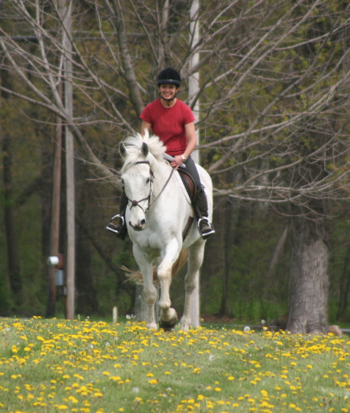
*Lake Erie College - 2002. B.S. Equine Science, Pre-vet.

*United States Pony Club; Certified Rater, Instructor, Coach and Horse Management Judge.

*Rolling Rock Hunt Pony Club; “C3” level graduate

*USEA Certified Safety Coordinator

*American Health Care Academy certified CPR/AED/First Aid- infant, child & adult.

*United States Eventing Association; Intermediate, CCI*, Member # 78443

*United States Hunter Jumper Association: Member # 282457

*United States Equestrian Federation: Eventing & Show Jumping, Member # 282457

Coaching Accomplishments:

2017 USPC Nationals Coach- Show Jumping
2017 Tri-State Regional Show Jumping & Dressage Coach
2016 USPC Nationals Coach- Show Jumping
2016 Tri-State Regional Show Jumping Coach
2015 USPC Nationals Coach – Games
2013-2015 Sunshine Region Coach- Show Jumping, Eventing, Games

Professional Riding Training: | Riding Awards and Accomplishments:
Stuart Pittman: Eventing, Thoroughbred Retraining  Bruce Davidson: Eventing  Joseph Hardiman: Show Jumping, Cross Country, Foxhunting  Howard Lewis: Hunters, Show Jumping  Jackie Smith: Eventing  Leigh Fisher: Show Jumping  Heather Walters: Dressage  Greg Best: Show Jumping  Ralph Hill: Eventing  Sue Hines: Eventing  Ite O’Higgins: Dressage, Eventing  Jurgen Gohler: Eventing, and Dressage  Henrietta Borst: Eventing  Brittany Sedlak: Eventing, Dressage  Kerri Gregg: Show Jumping, Eventing  Marlynna Pellegrini: Dressage  Julie McElhaney: Dressage  Kathy Henry: Dressage  Jim Greer: Western Riding | North America Adult Championship CCI*, 5th  USEA Intermediate Level Competitor 2007-2011  USEA Preliminary Level Competitor 2002-2014  North East Ohio High Point Rider, 2009  Lost Hounds High Point Rider; Preliminary Level, 2002  Area VIII Training Level Championships, 2001  Pony Club Nationals: Eventing; Training Level, 2001  Pony Club Nationals: Show Jumping; 1995, 1996, 1997  Rolling Rock Hunter Classic Champion 1996  Junior Rider of the Year 1996  Pony Clubber of the Year 1997  Junior Foxhunter of the Year 1997  Senior Rider of the Year 1998  Intercollegiate Horse Show Association: 1998-2002  1994-2000 ‘A’ Circuit Jumpers  Coon Ridge 4-H Club, 1994-1998  Foxhunted with Rolling Rock, Chagrin Valley, Sewickley, Keswick, Blue Ridge, Middleburg, Warrenton, Farmington, Grand River, Magnolia-Waynesburg, Palm Beach Hounds, Misty Morning & Lonesome Palm Hounds.

